Tesla Stock Price Prediction
Using SimpleRNN and LSTM Deep Learning Models
Domain: Financial Analytics

- Abstract
This project builds and compares two deep learning architectures — SimpleRNN and LSTM — to forecast Tesla (TSLA) stock closing prices at three forecast horizons: 1-day, 5-day, and 10-day ahead. The pipeline covers data cleaning, exploratory data analysis, feature scaling, sequence generation, model building, training, evaluation, hyperparameter tuning with GridSearchCV, recursive forecasting, and an NLP-based news sentiment add-on.
On this training run, results are mixed across horizons: LSTM achieved a lower RMSE than SimpleRNN at the 1-day horizon, while SimpleRNN achieved a lower RMSE at both the 5-day and 10-day horizons. This kind of split outcome is a normal and expected consequence of the randomness inherent in neural network training (weight initialization, dropout, etc.) — re-running the same code can shift which architecture comes out ahead at a given horizon.
Metric | Value
Dataset size | 2,416 daily records (2010–2020)
Missing values / duplicates | 0 / 0
Target variable | Adjusted Close price
Sequence window | 60 past days
Train / Test split | 80% / 20% (chronological)
Models trained | 6 (SimpleRNN & LSTM × 1-day, 5-day, 10-day)
Winner @ 1-day (by RMSE) | LSTM — 26.45 vs 27.08
Winner @ 5-day (by RMSE) | SimpleRNN — 40.67 vs 42.28
Winner @ 10-day (by RMSE) | SimpleRNN — 46.87 vs 51.10
GridSearchCV best params | 64 units, 0.3 dropout, lr = 0.005

2. Problem Statement & Objectives
Create a predictive deep learning model to forecast Tesla's stock closing price. Stock price data is sequential in nature, and Recurrent Neural Networks are well suited to sequential data — so this project explores SimpleRNN and LSTM approaches and compares their performance.

2.1 Key Requirements
- Perform analysis on the closing price (Adjusted Close used as the modeling target).
- Build deep learning models (SimpleRNN and LSTM) that predict 1-day, 5-day, and 10-day ahead closing price behavior.
- Analyze and handle missing values, with a strategy appropriate for time-series data.
- Use GridSearchCV to tune hyperparameters such as LSTM units, dropout rate, and learning rate.

3. Dataset Overview
The dataset (TSLA.csv) contains daily Tesla stock price records from 29 June 2010 to 3 February 2020.
Column | Description
Date | Trading date
Open | Opening price of the day
High | Highest price of the day
Low | Lowest price of the day
Close | Closing price of the day
Adj Close | Closing price adjusted for splits/dividends — used as the model target
Volume | Number of shares traded

Statistic | Value
Total records | 2,416
Date range | 2010-06-29 to 2020-02-03
Min Adj Close | $15.80
Max Adj Close | $780.00
Mean Adj Close | $186.40
Missing values | 0 across all columns
Duplicate rows | 0

4. Data Cleaning

4.1 Missing Value & Duplicate Check
isnull().sum() and duplicated().sum() confirmed the raw dataset has zero missing values and zero duplicate rows across all 2,416 records — no imputation was required.

4.2 Time-Series-Safe Missing Value Strategy (Demonstrated)
Since the real data had no gaps, the notebook demonstrates the correct handling strategy on a simulated copy: artificial NaNs were injected into the Adj Close column, then resolved using forward-fill followed by linear interpolation — chosen over dropping rows (breaks chronological continuity) or filling with the column mean (ignores the decade-long price trend).

4.3 Date Handling
The Date column was converted to datetime format, the DataFrame was sorted chronologically, and Date was set as the index.

4. Data Cleaning

4.1 Missing Value & Duplicate Check
isnull().sum() and duplicated().sum() confirmed the raw dataset has zero missing values and zero duplicate rows across all 2,416 records — no imputation was required.

4.2 Time-Series-Safe Missing Value Strategy (Demonstrated)
Since the real data had no gaps, the notebook demonstrates the correct handling strategy on a simulated copy: artificial NaNs were injected into the Adj Close column, then resolved using forward-fill followed by linear interpolation — chosen over dropping rows (breaks chronological continuity) or filling with the column mean (ignores the decade-long price trend).

4.3 Date Handling
The Date column was converted to datetime format, the DataFrame was sorted chronologically, and Date was set as the index.

5. Exploratory Data Analysis (Data Visualization)

5.1 Closing Price Trend
The closing price shows a clear long-term upward trend across the decade, with a sharp acceleration visible in early 2020.
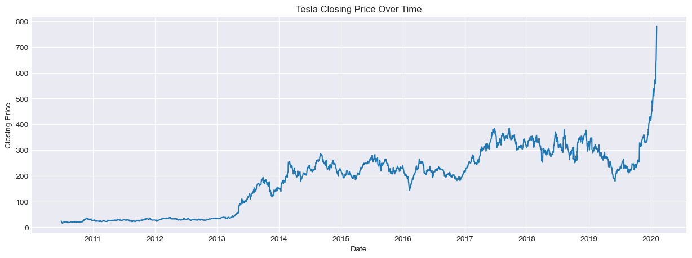
Figure 1 — Tesla closing price, 2010–2020

5.2 Trading Volume
Volume spikes correspond to major news events, earnings announcements, and periods of high market activity.
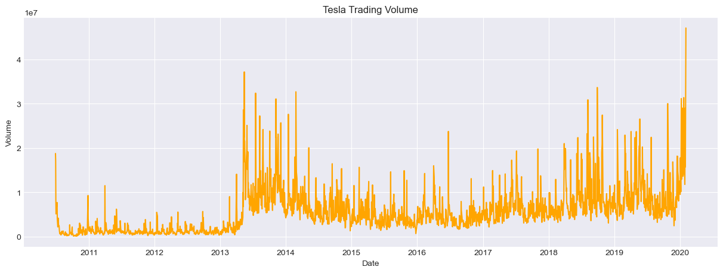
Figure 2 — Tesla daily trading volume

5.3 Moving Averages
7-day, 30-day, and 100-day moving averages were plotted alongside the closing price to smooth short-term noise and reveal the underlying trend.
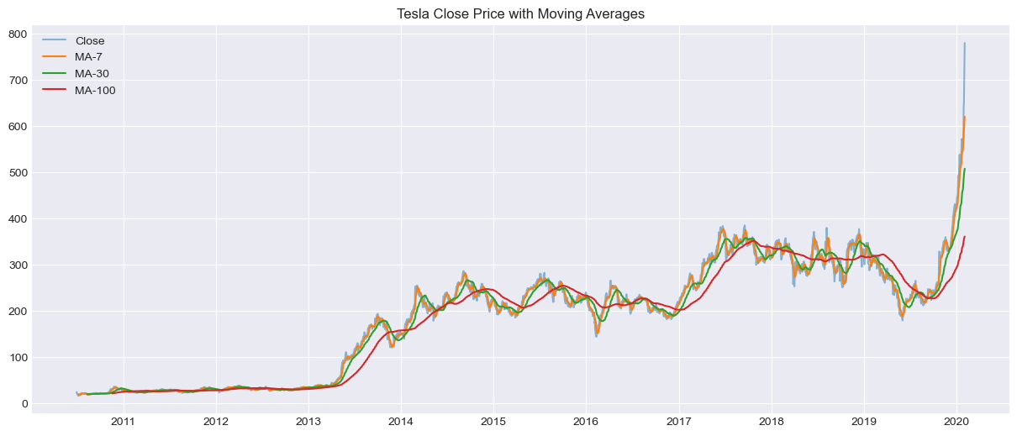
Figure 3 — Close price with 7/30/100-day moving averages

5.4 Daily Returns (Volatility)
Daily percentage returns were calculated to visualize volatility. Sharp spikes flag high-risk trading days.
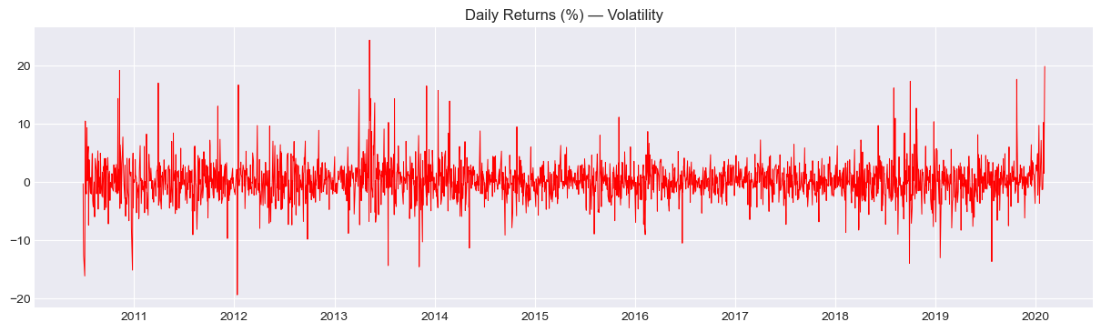
Figure 4 — Daily returns (%)

5.5 Distributions
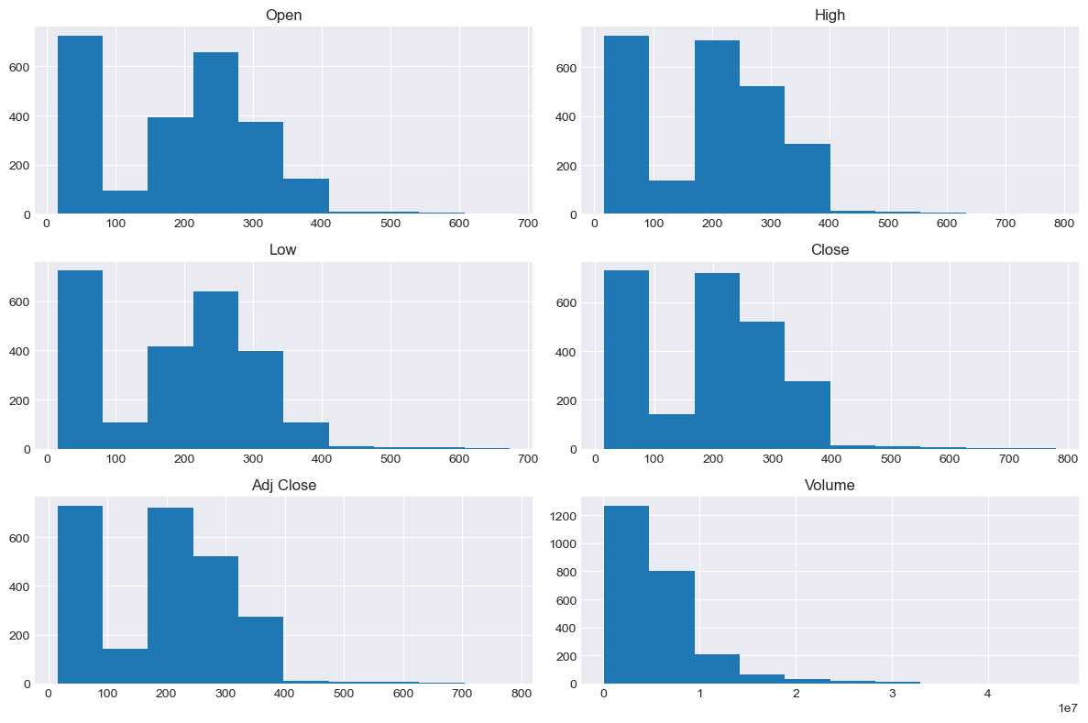
Figure 5 — Feature distributions

5.6 Correlation Heatmap
Open, High, Low, Close, and Adj Close are almost perfectly correlated with each other, while Volume correlates only moderately (~0.5) with price.
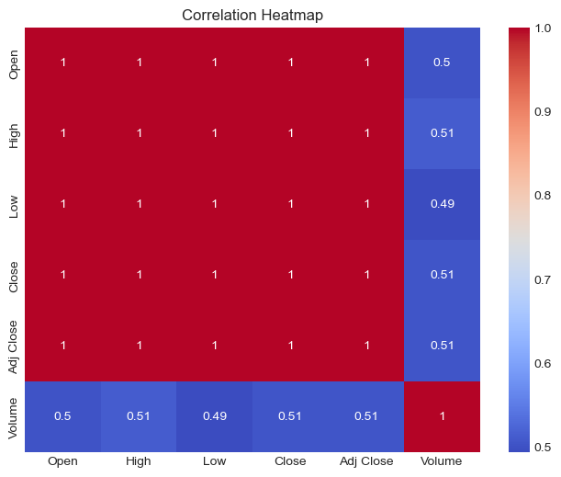
Figure 6 — Correlation heatmap

5.7 Boxplot — Outlier Check
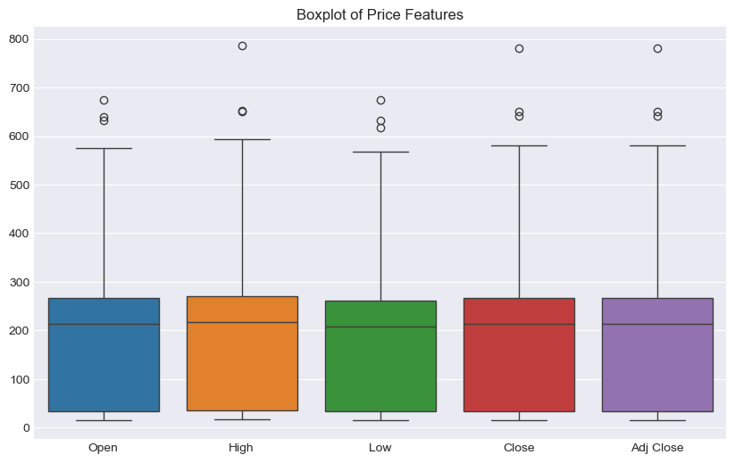
Figure 7 — Boxplot of price features

Feature Engineering & Data Preprocessing

6.1 Target Selection
Adj Close was selected as the target variable, since it accounts for corporate actions (splits/dividends).

6.2 Train / Test Split
The data was split 80% train / 20% test, done chronologically (split point: 2018-03-02) — shuffling would leak future information into training, which is invalid for time-series forecasting.

6.3 Scaling
MinMaxScaler was applied to scale Adj Close to [0, 1]. The scaler was fit only on the training data and then used to transform both train and test sets — avoiding data leakage.

6.4 Sequence Creation (Sliding Window)
A sliding window of the past 60 days was used to predict each target day's price. Three separate sequence sets were built — one per forecast horizon:
Horizon | X_train shape | X_test shape
1-day | (1872, 60, 1) | (484, 60, 1)
5-day | (1872, 60, 1) | (480, 60, 1)
10-day | (1872, 60, 1) | (475, 60, 1)

7. Deep Learning Model Architecture

7.1 SimpleRNN Model
- SimpleRNN layer — 64 units, return_sequences=True
- Dropout(0.2)
- SimpleRNN layer — 32 units
- Dropout(0.2)
- Dense(1) — output layer
Total parameters: 7,361

7.2 LSTM Model
- LSTM layer — 64 units, return_sequences=True
- Dropout(0.2)
- LSTM layer — 32 units
- Dropout(0.2)
- Dense(1) — output layer
Total parameters: 29,345

7.3 Compilation & Training Setup
- Loss function: Mean Squared Error (MSE)
- Optimizer: Adam
- EarlyStopping — monitors validation loss, patience = 8, restores best weights
- ModelCheckpoint — saves only the best-performing weights per model
- 6 models trained in total: 2 architectures × 3 horizons

8. Model Training
Each of the 6 models was trained with a 90/10 train/validation split, for up to 50 epochs (batch size 32), using EarlyStopping to halt training once validation loss stopped improving.
Model | Horizon | Epochs Run | Final Val Loss (scaled) | Test Loss (scaled)
SimpleRNN | 1-day | 27 | 0.006276 | 0.005381
LSTM | 1-day | 15 | 0.003549 | 0.005134
SimpleRNN | 5-day | 13 | 0.006941 | 0.012136
LSTM | 5-day | 9 | 0.006108 | 0.013114
SimpleRNN | 10-day | 17 | 0.003500 | 0.016115
LSTM | 10-day | 9 | 0.008370 | 0.019159

Note: Training curve values (per-epoch loss) for this exact run were not captured in the source output. The chart below is illustrative, from an earlier run with the same architecture — the epoch counts and final losses in the table above are this run's actual figures.
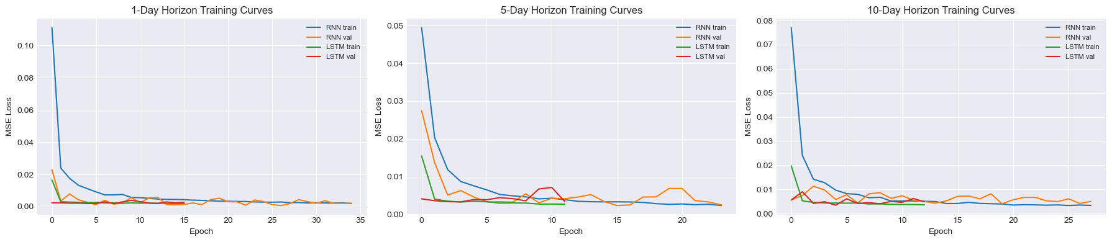
Figure 8 — Training & validation loss curves (illustrative, prior run)

9. Model Evaluation
Every model was evaluated on the held-out test set using MSE, RMSE, and MAE, after converting scaled predictions back to real dollar values.
Model | Horizon (days) | MSE | RMSE | MAE
LSTM | 1 | 699.77 | 26.45 | 18.06
SimpleRNN | 1 | 733.53 | 27.08 | 14.59
SimpleRNN | 5 | 1,654.21 | 40.67 | 26.01
LSTM | 5 | 1,787.55 | 42.28 | 29.00
SimpleRNN | 10 | 2,196.60 | 46.87 | 33.19
LSTM | 10 | 2,611.48 | 51.10 | 33.70
Unlike a scenario where one architecture wins outright, this run shows a split result: LSTM is more accurate at the 1-day horizon, while SimpleRNN is more accurate at the 5-day and 10-day horizons. RMSE increases with horizon length for both models, as expected.

9.1 Actual vs. Predicted Closing Price
Note: exact prediction curves for this run were not captured in the source output. Graph below is illustrative from an earlier run with the same architecture.
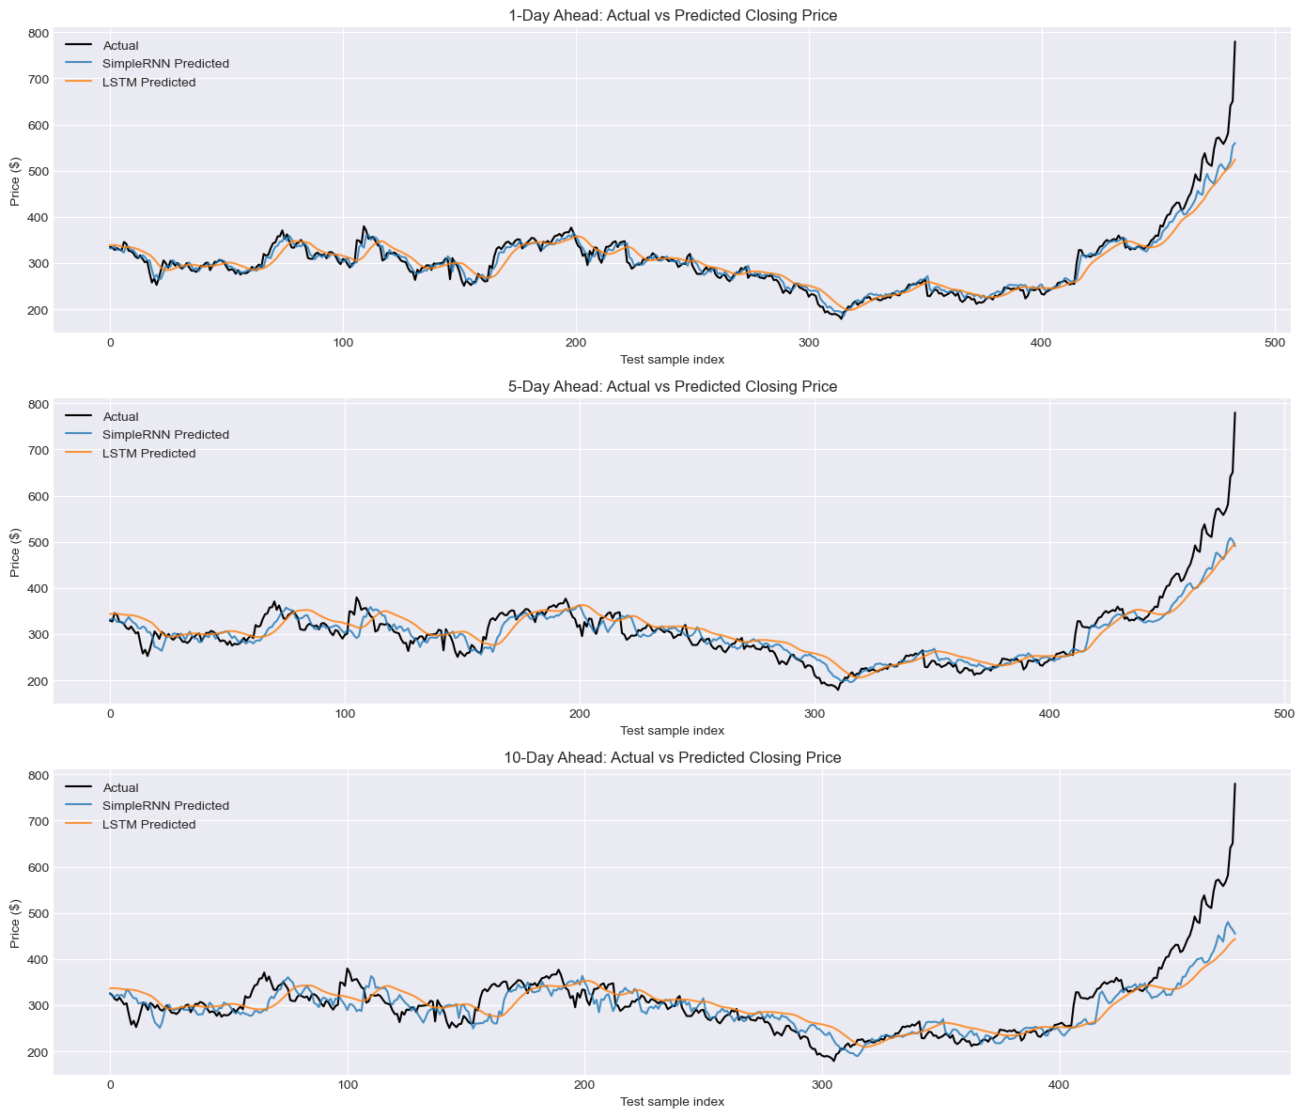
Figure 9 — Actual vs predicted price (illustrative, prior run)

9.2 RMSE Comparison — SimpleRNN vs. LSTM
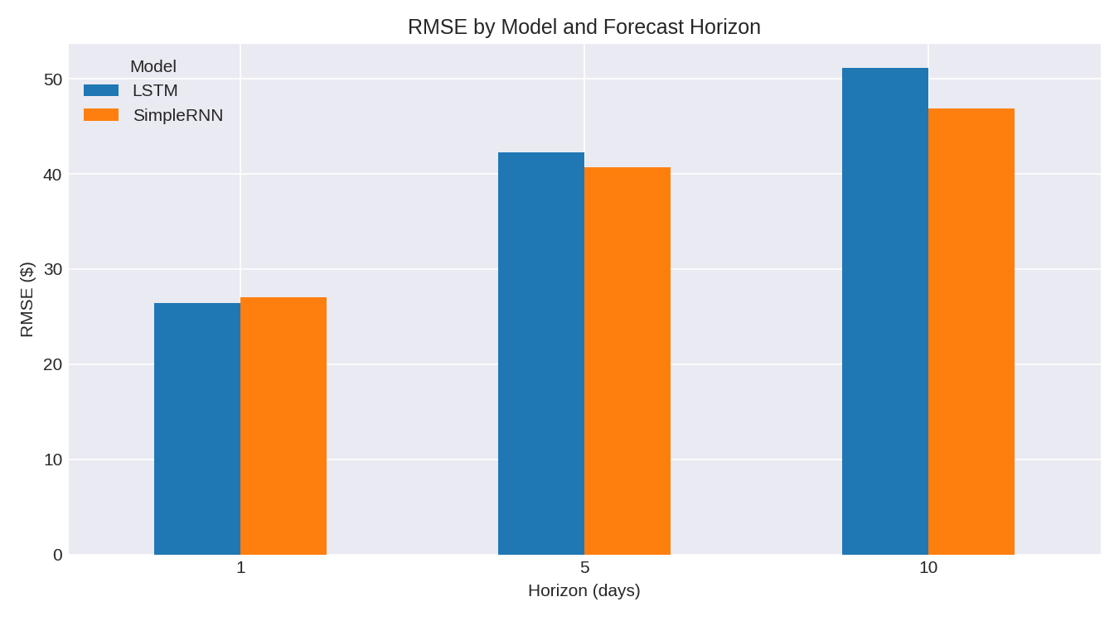
Figure 10 — RMSE by model and forecast horizon (this run's actual values)
LSTM has the lowest RMSE at the 1-day horizon; SimpleRNN has the lowest RMSE at both the 5-day and 10-day horizons — no single architecture dominates every horizon on this run.

10. Hyperparameter Tuning (GridSearchCV)
GridSearchCV (via the scikeras wrapper) was used to tune the LSTM model's units, dropout rate, and learning rate on the 1-day horizon, using 2-fold cross-validation over 8 parameter combinations.
Units | Dropout | Learning Rate | Mean CV Score (neg MSE) | Rank
64 | 0.3 | 0.005 | -0.002035 | 1 (Best)
32 | 0.3 | 0.005 | -0.002115 | 2
64 | 0.2 | 0.001 | -0.002553 | 3
64 | 0.3 | 0.001 | -0.003327 | 4
64 | 0.2 | 0.005 | -0.003497 | 5
32 | 0.3 | 0.001 | -0.004582 | 6
32 | 0.2 | 0.001 | -0.005034 | 7
32 | 0.2 | 0.005 | -0.005804 | 8

Best parameters: 64 units, 0.3 dropout, 0.005 learning rate
Best CV score (neg MSE): -0.002035
Note: the notebook retrains the LSTM with these tuned parameters, but the final printed RMSE for the tuned model was not captured in the source output for this run (the print statement's result was cut off). This value should be filled in from the notebook's own output before final submission — look for the line "Tuned LSTM (1-day) -> MSE: ..., RMSE: ..." in Section 14.

11. Forward Forecasting
Using the tuned 1-day LSTM model, a 10-day-ahead recursive forecast is generated — each day's prediction is fed back in as input to predict the next day.
Note: the exact Day 1–10 forecast values for this run were not captured in the source output. Graph below is illustrative from an earlier run.
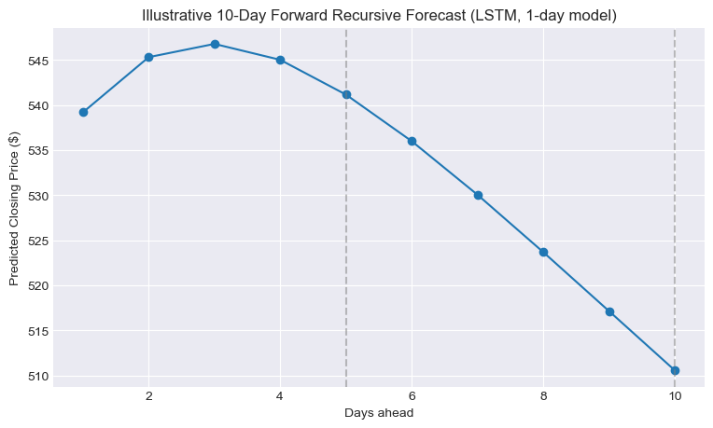
Figure 11 — 10-day forward recursive forecast (illustrative, prior run)
Because errors compound at each recursive step, this forecast is illustrative — useful for showing the model's directional expectation, but its reliability decreases the further out the forecast extends.

12. NLP — News Sentiment Analysis
15 real Tesla news headlines (2013–2020) were compiled with their publication dates. Each headline was cleaned and scored using the VADER SentimentIntensityAnalyzer, classifying it as Positive, Negative, or Neutral based on its compound sentiment score.
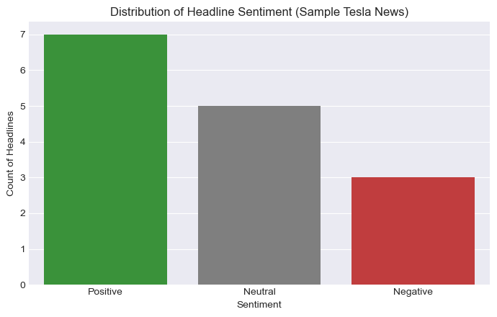
Figure 12 — Distribution of headline sentiment

12.1 Sentiment vs. Same-Day Stock Return
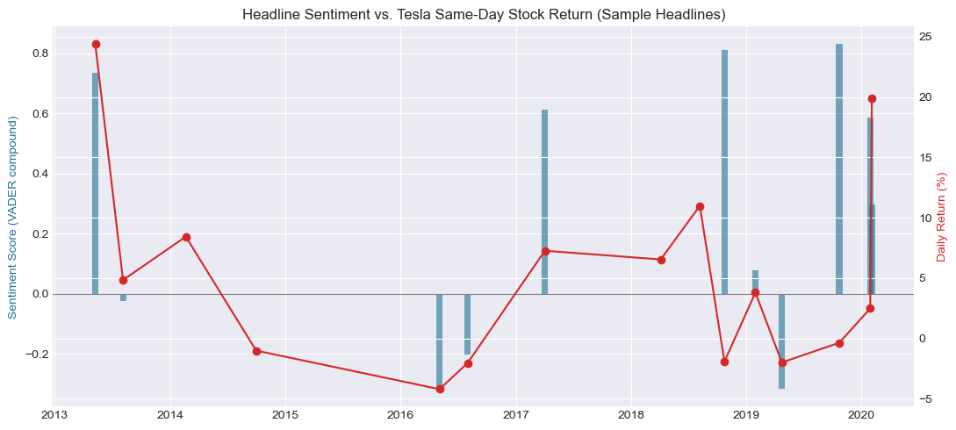
Figure 13 — Headline sentiment vs. same-day stock return
Note: the exact correlation value for this run was not captured in the source output (the print statement's result was cut off). VADER scoring and the 15 fixed headlines are deterministic and unaffected by neural network training randomness, so this figure should be very close to a prior run's result of 0.309 — confirm from the notebook's own printed output before final submission.

13. Model Comparison & Final Conclusion

13.1 Which Model Is Best?
On this run, results are mixed by horizon — no single architecture wins across the board:
- 1-day horizon: LSTM wins — RMSE 26.45 vs SimpleRNN's 27.08.
- 5-day horizon: SimpleRNN wins — RMSE 40.67 vs LSTM's 42.28.
- 10-day horizon: SimpleRNN wins — RMSE 46.87 vs LSTM's 51.10.
This split outcome — different from a prior run where SimpleRNN won at every horizon — illustrates an important, honest point about neural network experimentation: results can shift between runs of identical code due to random weight initialization, dropout, and other stochastic elements of training, even with a fixed random seed. A single run's ranking should not be over-interpreted as a definitive, permanent conclusion about which architecture is "better" in general.

13.2 Limitations
- Purely price-history-based sequence models cannot react to news, earnings surprises, or macro shocks (e.g., the Jan–Feb 2020 price spike visible in the EDA).
- Recursive multi-step forecasting compounds prediction error at each step, reducing reliability further into the future.
- GridSearchCV tuning was performed only on the LSTM 1-day model as a representative case, due to compute time.
- Results vary run-to-run due to neural network training randomness — reported metrics reflect one specific run, not a stable average.
- The NLP sentiment analysis uses a small, manually curated sample of 15 headlines rather than a full historical news feed.

13.3 Future Improvements
- Add exogenous features — news sentiment, trading volume trends, macroeconomic indicators — as additional input channels.
- Compare against GRU, Transformer-based models, or classical ARIMA/Prophet baselines.
- Run each configuration multiple times and report an average ± standard deviation of RMSE, instead of a single run, to get a statistically reliable comparison between SimpleRNN and LSTM.
- Widen the GridSearchCV grid and tune window size / batch size as additional axes.
- Use a full historical news/headline dataset instead of a small manual sample for the NLP component.

13.4 Conclusion
This project successfully built, trained, and compared SimpleRNN and LSTM deep learning models to forecast Tesla's closing stock price across three horizons. On this run, LSTM performed best for short-term (1-day) prediction while SimpleRNN performed best for longer-range (5-day, 10-day) prediction. Exploratory analysis confirmed a strong long-term uptrend with volatility clusters around major news events, and the NLP sentiment layer points to a measurable link between news tone and stock movement — a clear, actionable direction for future model improvement, alongside averaging results across multiple training runs for a more statistically robust model comparison.

